**Final Report**

**On**

**Plan Your Trip Web App**

**By**

**Yogesh Singh**

**11715065**

**26**

**Submitted to: Neha Sharma**

**Introduction:**

Plan My Trip is an e-platform where a user can book flights or other transportation methods to reach their destination. This project has a admin access, which can be used to add, delete, and edit pages in the website. Admin can also provide new destinations and transportation methods, and save them in the database.

**Technologies used:**

* Nodejs
* Express
* Mongoose (GUI- MongoDB Compass)
* HTML, CSS, JS, Bootstrap

**Modules:**

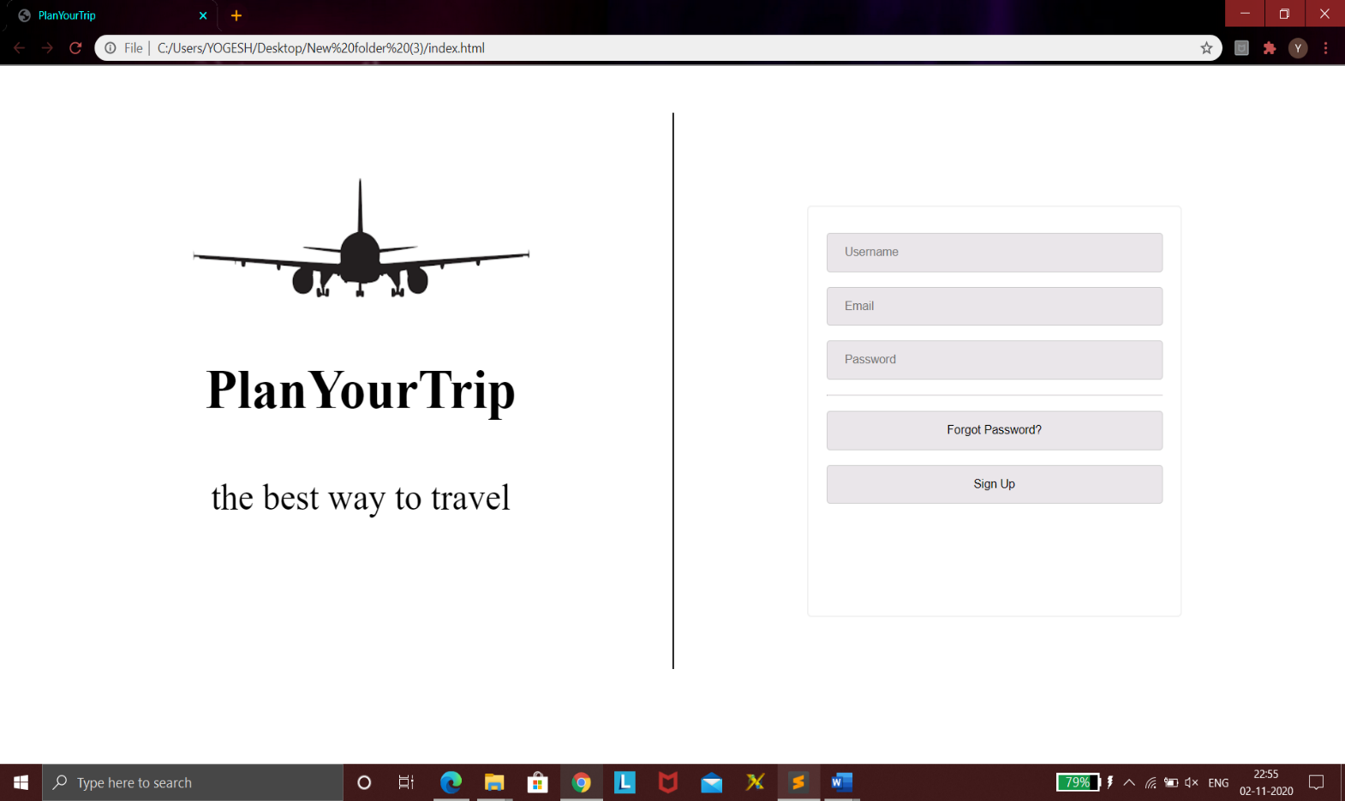

Above is a login page linked to signup page below. After Sign Up we are directed to login page again.

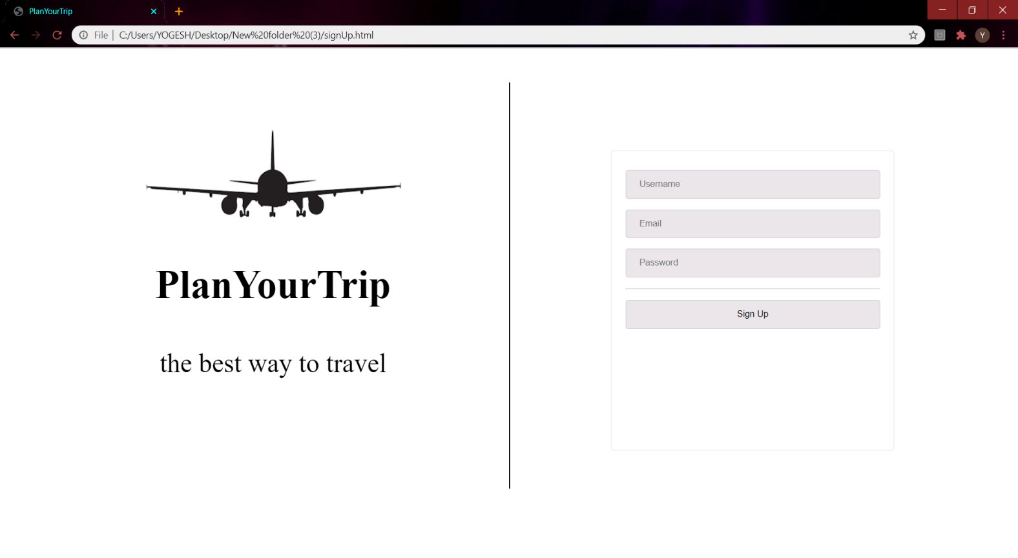

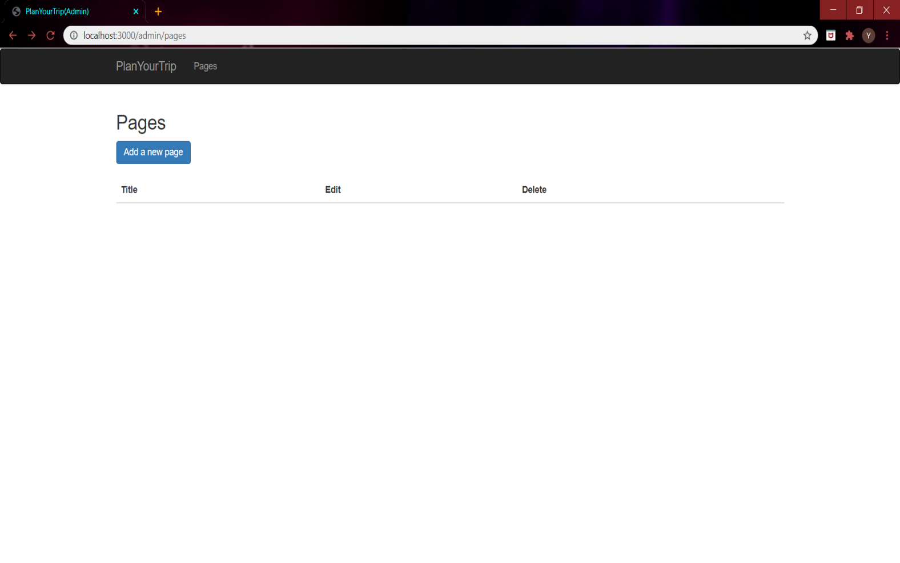

Above is an Admin access page, where all the pages in the server are shown. Admin can add a page by clicking at “Add a new page” button. After clicking on the button, admin is redirected to below shown page, where he can add a page by filling the form.

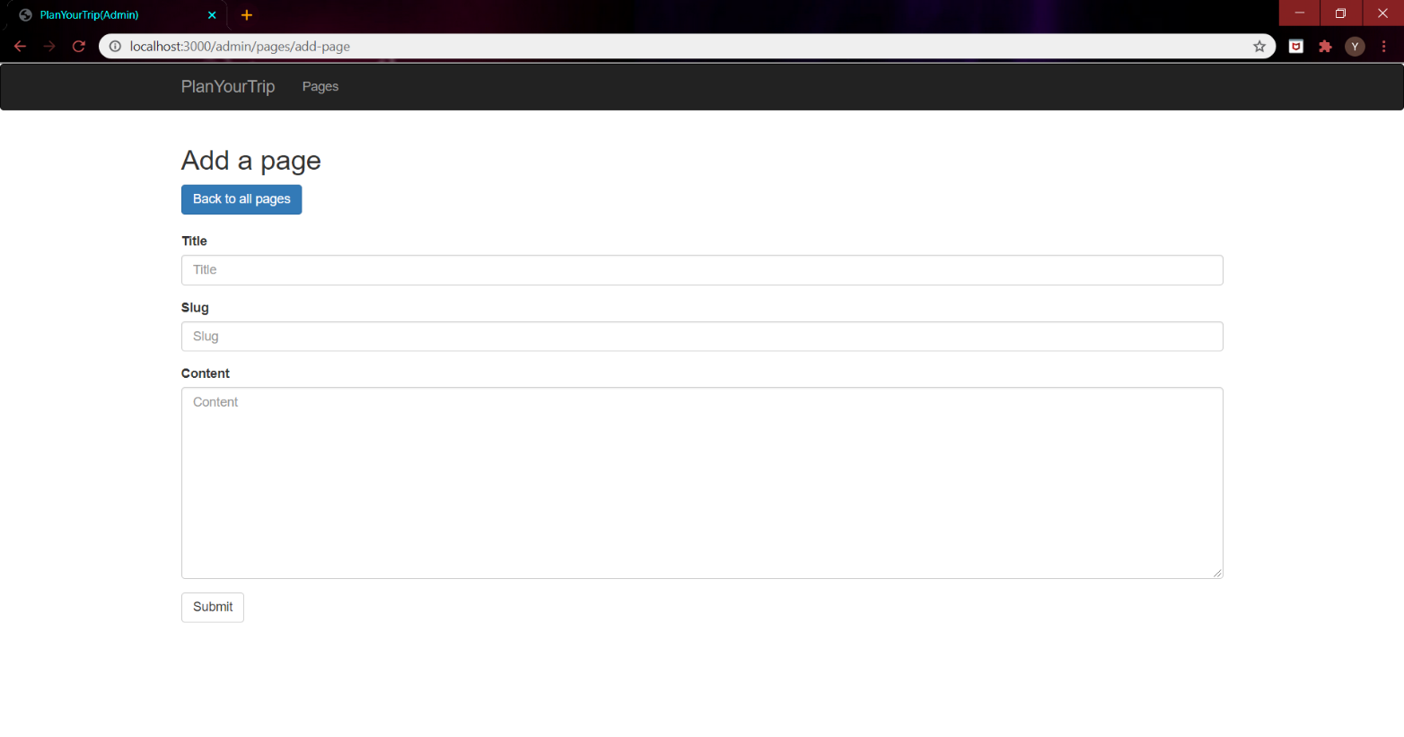

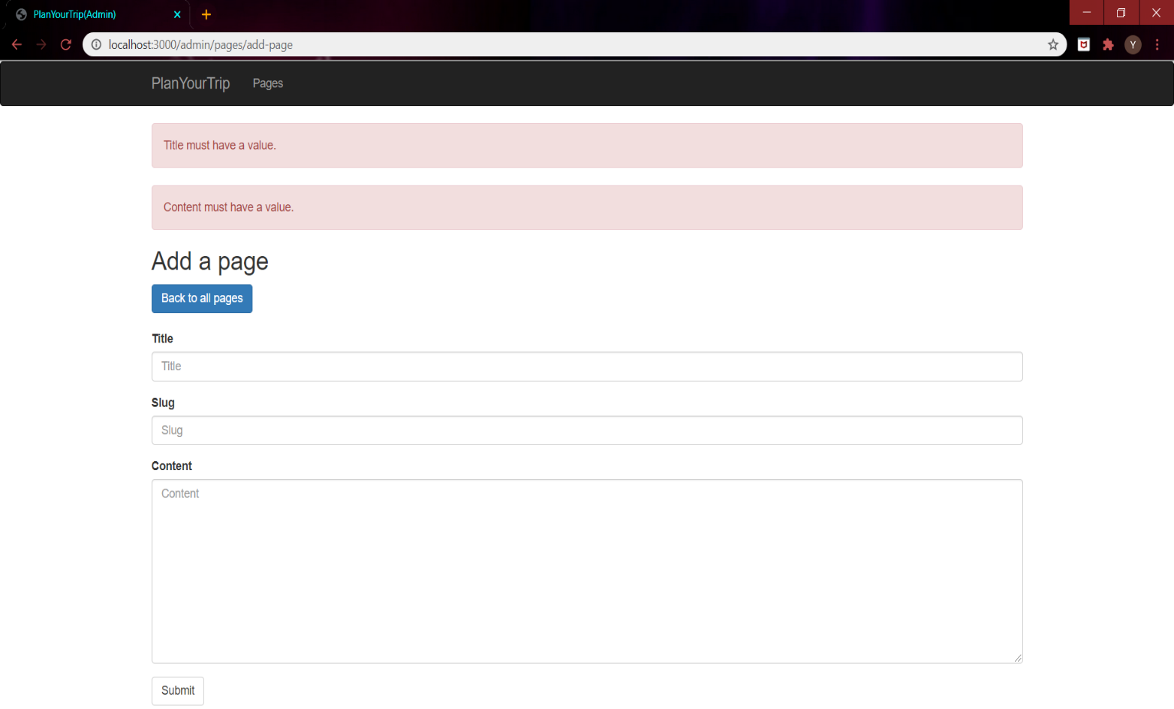

While filling the new page form, admin can’t leave the TITLE and CONTENT fields empty, otherwise, error messages are highlighted, as shown in above page. Moreover, the content should be unique, i.e., not present in database, otherwise, error message is highlighted, as shown in below page.

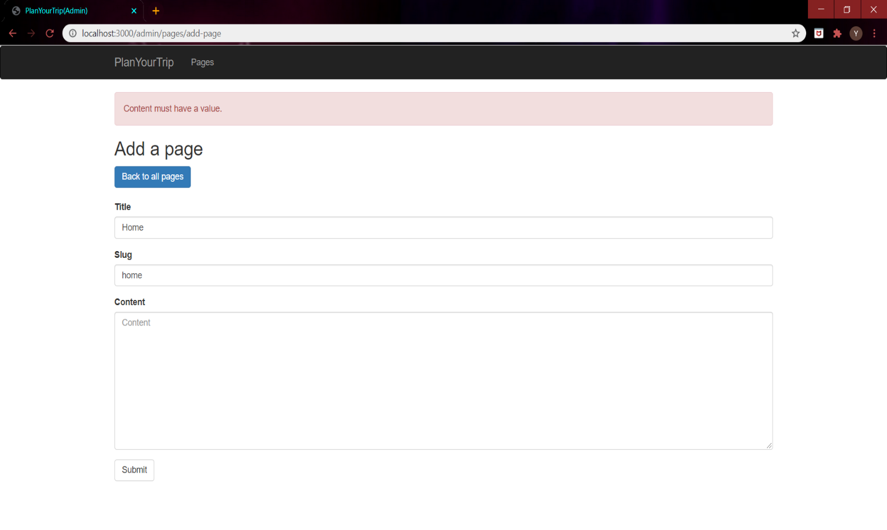

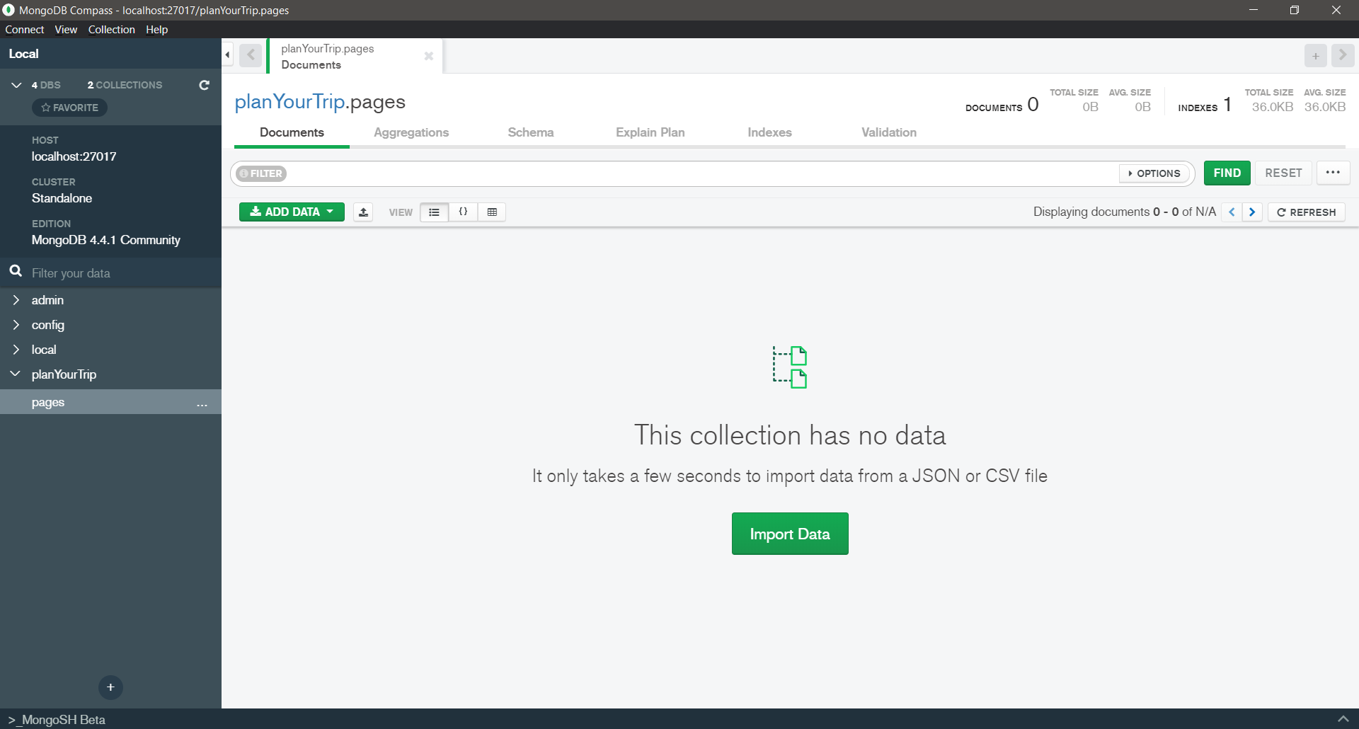

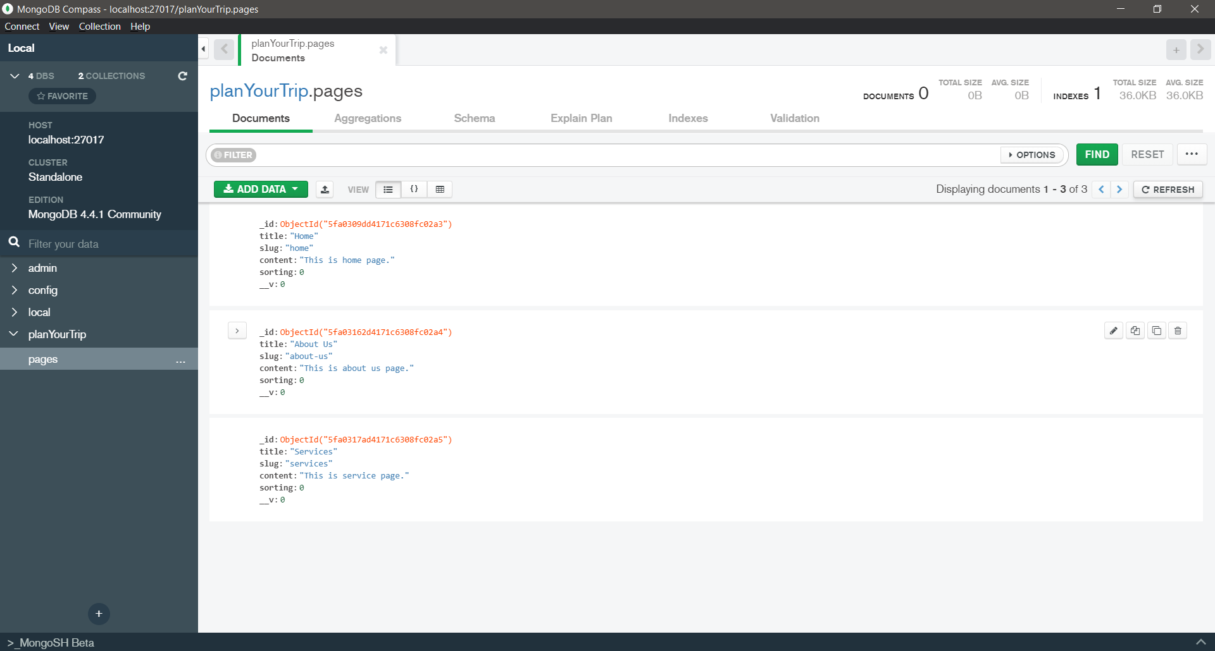

The two snaps present above are from mongoDB Compass, which is a GUI to use MongoDB. The first snap is before the time of adding any page by the admin, and latter is the one after adding three pages.

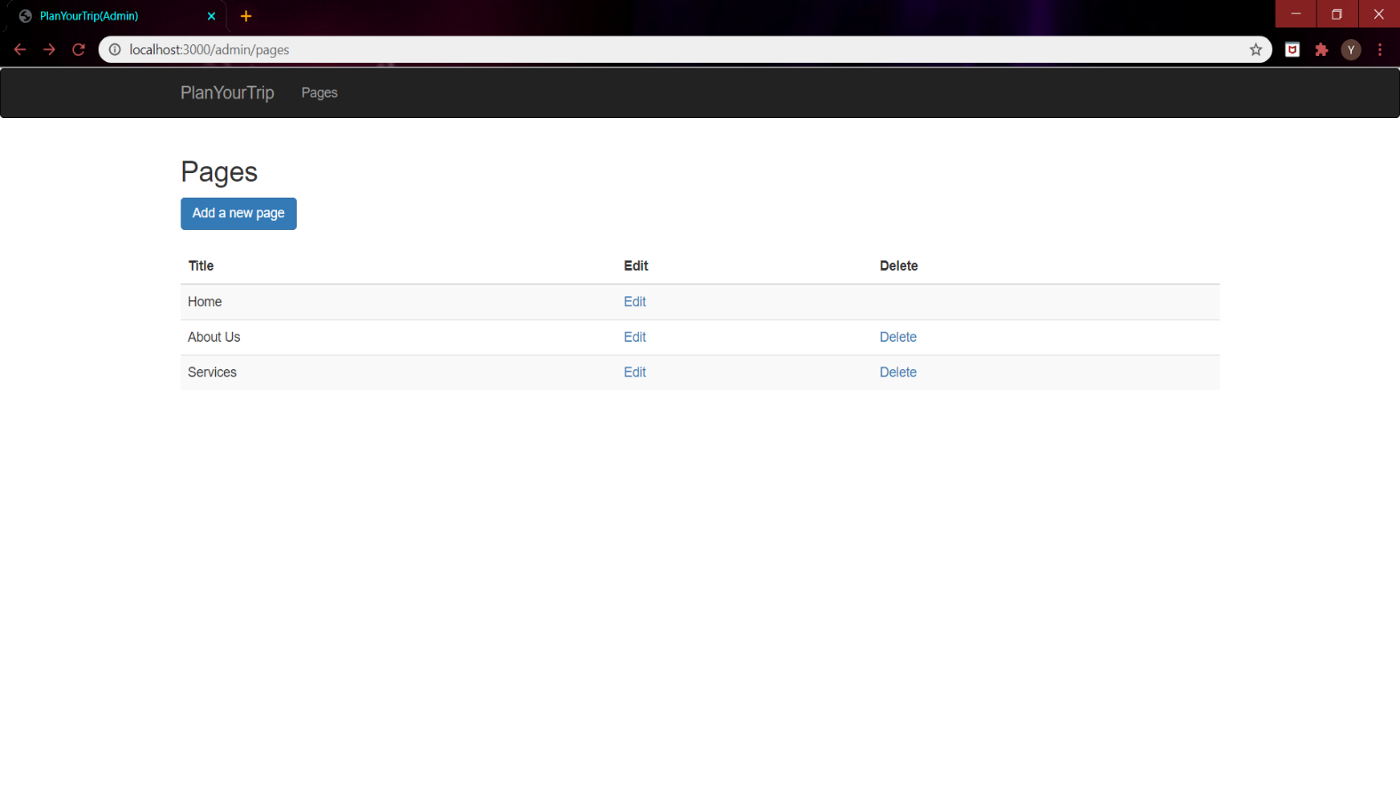

The above snap is from the admin access page, after adding three pages in the database. The admin can edit and delete the pages.

**GitHub:**

https://github.com/Yogesh-28/planYourTrip